**What is mongodb atlas ?**

MongoDB Atlas is a fully managed cloud database service provided by MongoDB, the creators of the open-source MongoDB database.

In essence, it takes away the burden of managing and scaling your MongoDB database deployments. You get to focus on building and innovating your applications, while Atlas handles the infrastructure and operational tasks like:

* **Deployment and Management**: Easily create and manage MongoDB clusters across various cloud providers like AWS, Azure, and Google Cloud.
* **Scaling**: Handles both horizontal and vertical scaling to adapt to your application's needs, optimizing for performance and cost.
* **Backups and Recovery**: Provides automated backups and data recovery features for data safety and resilience.
* **Security**: Offers enterprise-grade security features like access controls, encryption, and automatic updates to protect your data.
* **Performance Optimization**: Includes tools and features for monitoring and optimizing your database performance.

Key takeaways

* MongoDB Atlas is a Database-as-a-Service (DBaaS) for MongoDB.
* It simplifies deployment, management, and scaling of MongoDB databases in the cloud.
* It's a multi-cloud solution, allowing deployments on AWS, Azure, and Google Cloud.
* Atlas offers different cluster tiers, including a free tier for testing and a flexible pay-as-you-go model.
* It integrates with various tools and services within the MongoDB ecosystem and popular cloud services.

**What is MongoDB Atlas?**

MongoDB Atlas is a cloud-based service that makes it easy to use MongoDB in the cloud, so you don’t have to worry about setup or maintenance. Instead of dealing with the technical details of running a database, Atlas handles the hard stuff for you like scaling, backups and security, so you can focus on building your app or project.

It works with the major cloud providers—**AWS**, **Google Cloud**and **Microsoft Azure,**which means you can choose where your data lives. It is designed to be reliable and always available, so you don’t have to worry about downtime

**Key Features of MongoDB Atlas**

[MongoDB Atlas](https://www.geeksforgeeks.org/mongodb/mongodb-compass-vs-mongodb-atlas/) is packed with features that make **managing databases** in the cloud simple and efficient. From **automated backups** to advanced security, Atlas provides everything needed for modern**application development**.

**1. Fully Managed Cloud Database**

MongoDB Atlas automates **database maintenance** tasks such as **setup**, **scaling**, and updates. This allows developers to focus on building applications instead of managing **database infrastructure**.

**2. Global Cluster Deployment**

Atlas supports **global clusters**, allowing data to be distributed across multiple regions. This ensures **low-latency access** for users worldwide and makes applications highly available.

**3. Advanced Security Features**

* **Encryption**: Ensures data is secure both in transit and at rest.
* **Access Control**: Role-based access management for users.
* **IP Whitelisting**: Restricts database access to trusted IPs only.

**4. Automated Backups and Recovery**

With Atlas, we can schedule regular backups and restore data to a specific point in time. This feature ensures **data integrity** even in case of accidental deletion or hardware failure.

**5. Real-Time Performance Monitoring**

MongoDB Atlas provides in-depth monitoring tools to visualize database performance, helping you optimize queries and ensure smooth operations.

**6. Seamless Integration**

Atlas integrates effortlessly with modern development tools and frameworks, including [MongoDB Compass](https://www.geeksforgeeks.org/mongodb/mongodb-compass/), **MongoDB Shell**, and application drivers for languages like Node.js, Python, and Java.

**Advantages of MongoDB Atlas**

Here are the key advantages of using MongoDB Atlas that make it a preferred choice for developers and businesses:

**1. Easy to Access and Use**

MongoDB Atlas offers a cloud-based interface accessible from any device with an internet connection. Its intuitive dashboard simplifies [cluster management](https://www.geeksforgeeks.org/computer-networks/what-is-cluster-management-system/)and**database operations**.

**2. Cost Efficiency**

It follows a **pay-as-you-go principle,**which means that users have to only pay for the resources they consume. It also provides a free tier (M0 Cluster) for learning and experimentation.

**3. Security**

It includes security features such as **Encryption**, **Access Control List**, **Authentication** and Network isolation. It also ensures the **integrity**and **confidentiality** of the user data.

**4. Automated Backup and Recovery**

It also has a **Backup**and **recovery**feature by which users can backup and recover their data. Users can schedule regular backups and restore the database to specific points in time.

**5. Reliability and High Availability**

By providing a feature like **Automated backup** and recovery it ensures that even in hardware failure it is available and can reliably transfer data.

**6. Data Visualization Tool**

It provides a [data Visualization](https://www.geeksforgeeks.org/data-visualization/data-visualization-and-its-importance/) feature by which you can plot your data in different charts and extract knowledge from it.

**7. Easy installation and Integration**

It provides step by step guide to connecting the cloud database with Application, Compass, and [Shell](https://www.geeksforgeeks.org/linux-unix/introduction-linux-shell-shell-scripting/). And step-by-step guide to Installing a **driver**to connect an application.

**8. Data API**

It provides an **Application Programming Interface** ([API](https://www.geeksforgeeks.org/software-testing/what-is-an-api/)) feature by which you can access data through [HTTP](https://www.geeksforgeeks.org/blogs/http-full-form/)requests. It is a middleware service that lies between the user's cluster and the clients that send requests.

**9. Community and Support**

It has a huge community of developers, So you can get any help you need. users can access a resources, including documentation, forums, tutorials and receive support from MongoDB experts to address any issues or challenges.

**How to Get Started with MongoDB Atlas**

**Step 1: Create a MongoDB Atlas Account**

* To create a MongoDB Atlas Account, You need to visit the [MongoDB Atlas website](https://www.mongodb.com/cloud/atlas/register)
* Register yourself with an **Email Id**, **Google**or [GitHub](https://www.geeksforgeeks.org/git/introduction-to-github/) account

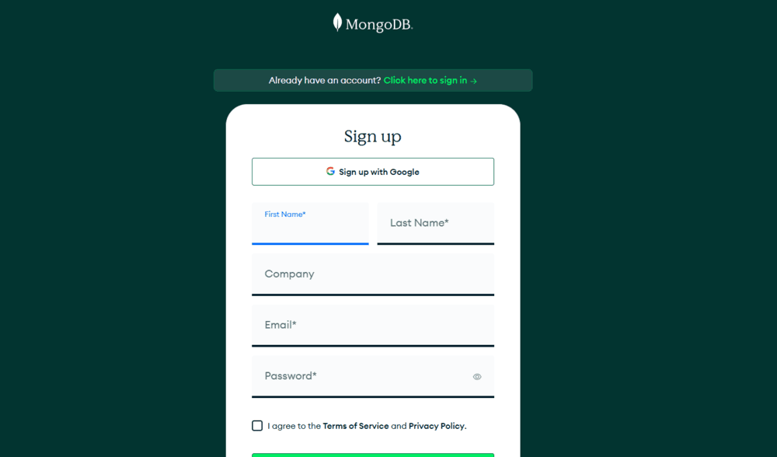

**Step 2: Create a New Cluster**

* After registration, set up a cluster by selecting a provider (AWS, Google Cloud, or Azure).
* Choose the **M0 Free Tier** for practice or select a **paid plan** for production use.

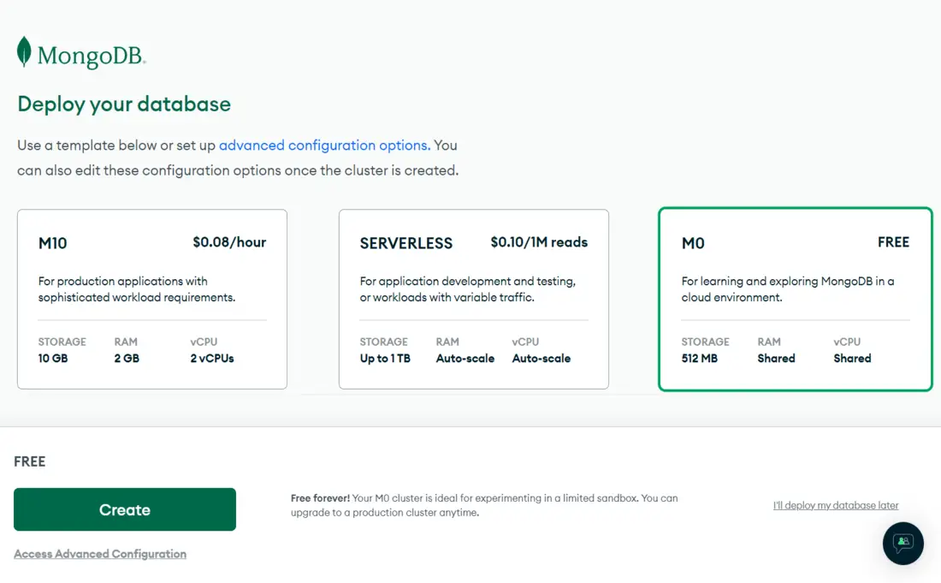

**Setting Up a MongoDB User for Your Cluster**

**Step 1: Navigate to the Database Access Page**

* To create a new user, In Side Bar you will find a **Database Access**page in the **Security**section.
* Open that page and click on the **ADD NEW DATABASE USER** button on the top right hand side to create a new user.

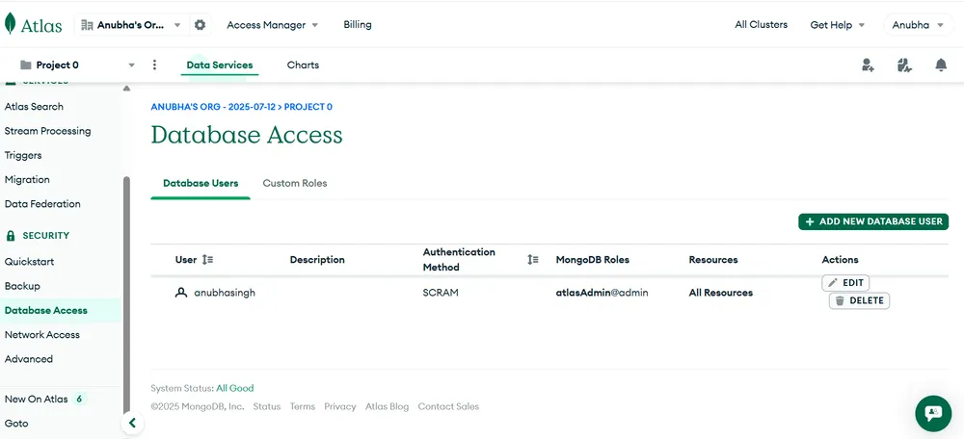

**Step 2: Configuration of a new user**

* After completing step 1 you have to enter a **USERNAME**and **PASSWORD.**then scroll down to Configure [Database User Privileges](https://www.geeksforgeeks.org/mongodb/create-user-and-add-role-in-mongodb/)**.**
* In Database User Privileges you have to choose the appropriate role for the user or create a temporary user if needed.
* After doing this click on **Add User**button to create a new user.

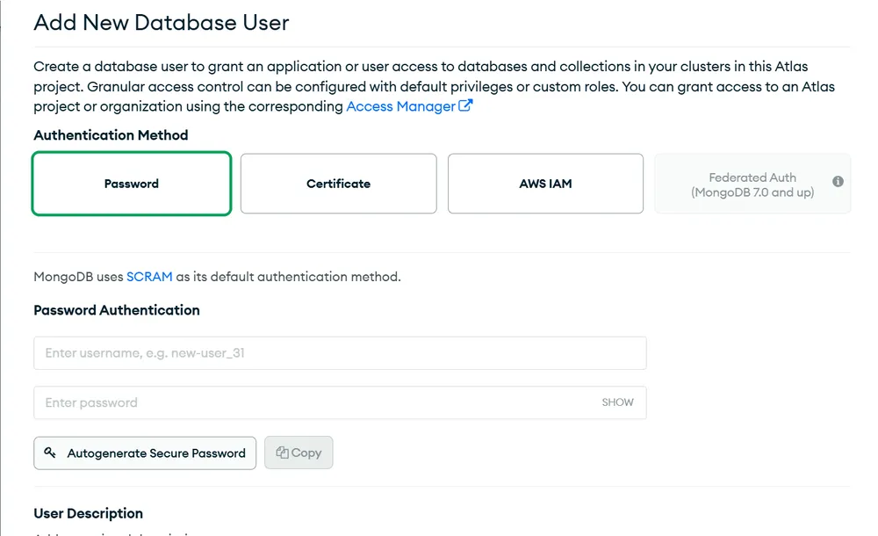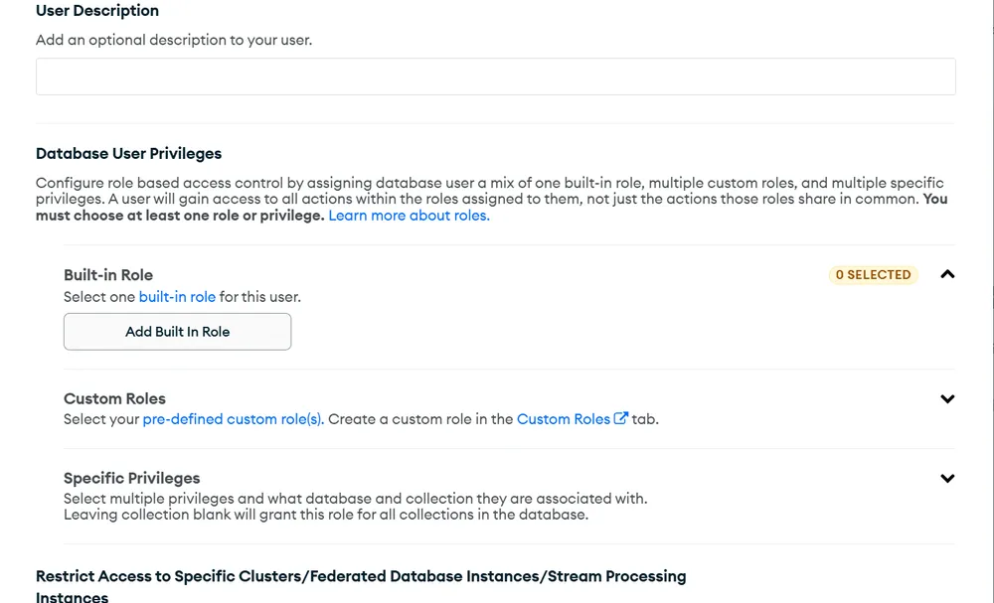

***Note:*** *Make sure to save the username and password in a secure place. You will need these credentials later when connecting to MongoDB Atlas using tools like MongoDB Compass or when integrating with your application.*

**Configuring IP Whitelisting**

**Step 1: Navigate to Network Access**

* To configure this, In Side Bar you will find a [Network Access](https://www.geeksforgeeks.org/computer-networks/what-is-network-access-control/)page in the **Security** section.
* Open that page and click on the **ADD IP ADDRESS**button to add a new IP Address

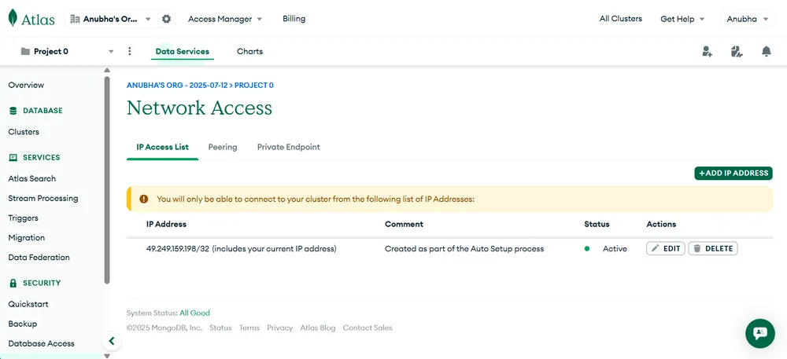

**Step 2: Add Access IP Address**

* If you want to add your current IP Address then click on **ADD CURRENT IP ADDRESS**button. It is recommended to add **0.0.0.0/0**int he **Access List Entry**so anyone with a Username and Password can Access the Database with Any Network.
* You can add a **0.0.0.0/0**IP Address by clicking on the **ALLOW ACCESS FROM ANYWHERE** button. You can also create an Access IP for Temporary use for some hours, a day or a week.
* After doing this, click on the **Confirm**button to add an IP Address to the Access List.

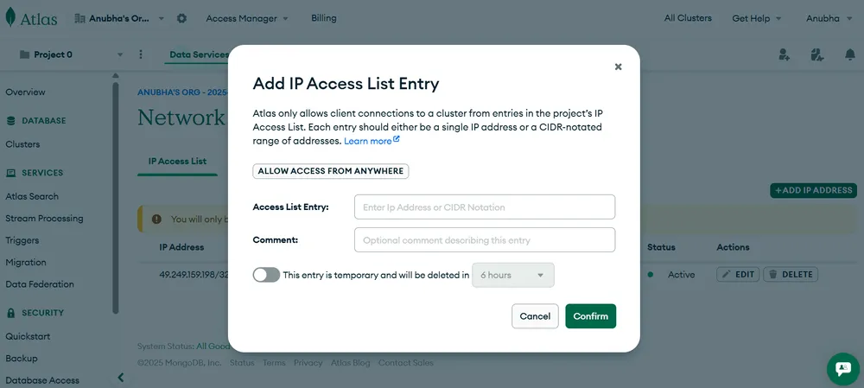

**Connecting to MongoDB Atlas**

**Step 1: Navigate to the Database Page**

* To connect with your cluster, In Side Bar you will find a **Clusters** page in the **Database**section.
* Open that page and click on the **Connect**button to get all possible ways to connect with your MongoDB Atlas Cluster.

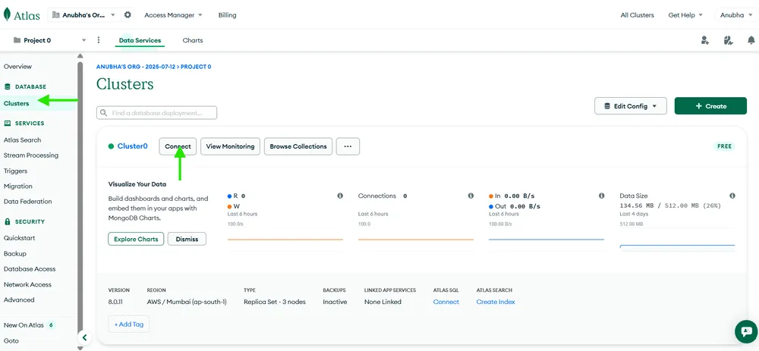

**Step 2: Choose Your Connection Method**

Now choose your desirable option to connect with your MongoDB Atlas Cluster and Follow the Instructions given there to connect with your MongoDB Atlas Cluster. You can connect your cluster with the application by using Drivers.

* **Connect with Application**: Use drivers for Node.js, Python, Java, etc.
* **MongoDB Compass**: Connect via MongoDB’s GUI tool.
* **MongoDB Shell**: Use the CLI to interact with your database.

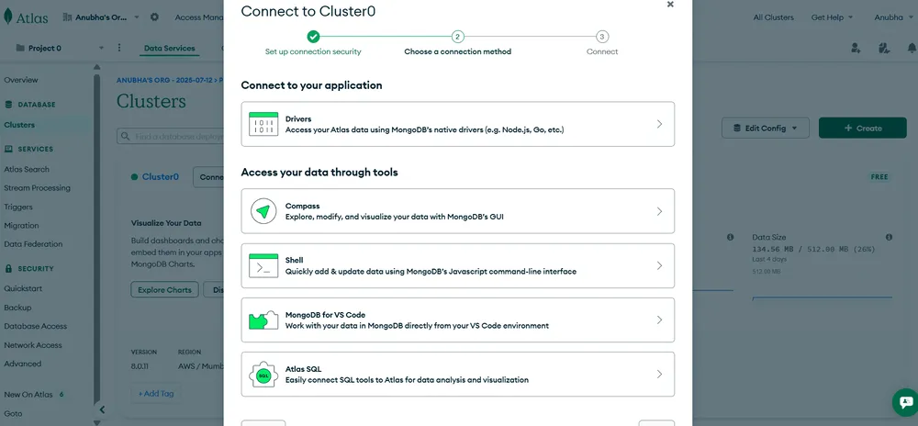

**Why Choose MongoDB Atlas?**

MongoDB Atlas simplifies **database operations** while providing **scalability**and **high performance**. Its powerful tools and security features make it ideal for businesses of all sizes. Whether you are a small startup or a large enterprise, MongoDB Atlas helps us build, deploy, and scale applications with ease.

**Use Cases:**

1. **Web Applications**: Integrate with MEAN or MERN stacks for modern, scalable web apps.
2. **E-commerce**: Manage catalogs, user carts, and real-time inventory.
3. **Real-Time Gaming**: Handle player profiles and live interactions.
4. **Data Analytics**: Process large datasets and visualize results.

**Conclusion**

* MongoDB Atlas is a cutting-edge, fully managed[cloud database](https://www.geeksforgeeks.org/computer-networks/google-cloud-database-services/) service that empowers developers to focus on building applications rather than managing database infrastructure.
* features like global clusters, advanced security, automated backups, and real-time monitoring, Atlas ensures a seamless [database](https://www.geeksforgeeks.org/dbms/what-is-database/) experience.
* MongoDB Atlas is the perfect solution for modern cloud-based applications, offering unmatched flexibility, performance and ease of use.